Dear reviewer

Online archive is no longer for free, but these are the steps that I would follow:

Screenshot of needing to upgrade to archive:

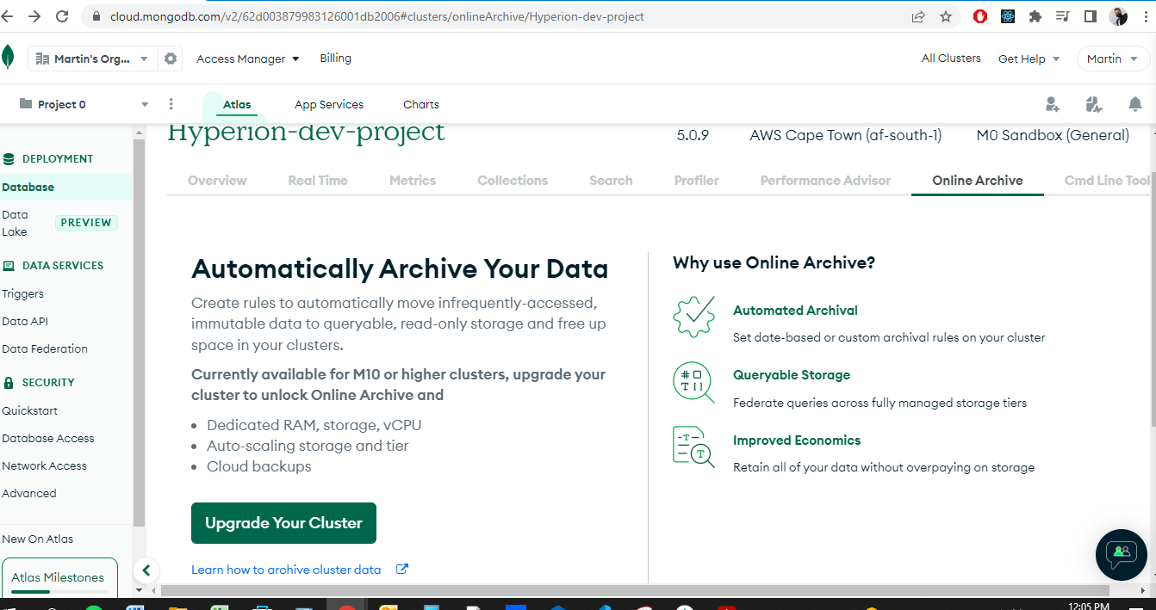

**Below is the steps of how I would go about doing it: Screenshots from MongoDB official video**

Step 1: Click Next

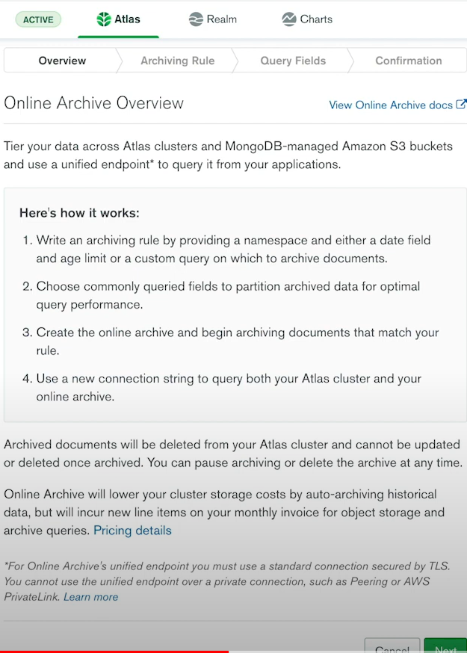

Step 2: Enter the name space – In our case “maintenance.maintenancejobs”

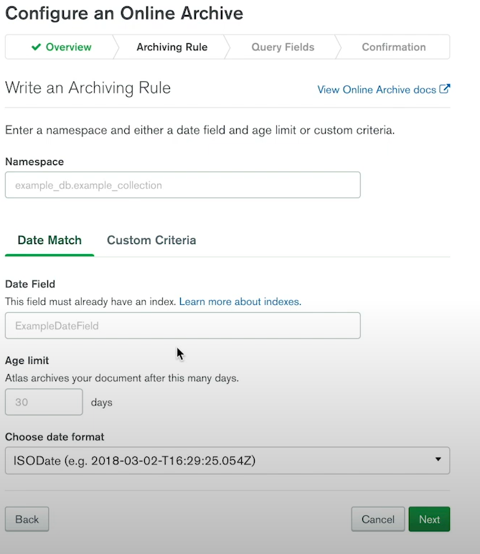

Step 3: Create a custom criteria

* {“archive” : true}

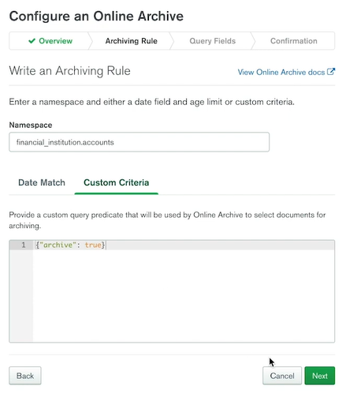

Step 4: Most commonly queried field

* _id

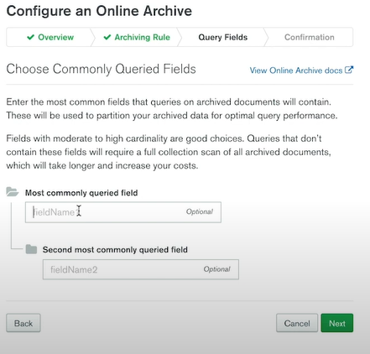

Step 5: Click on “Begin Archiving”

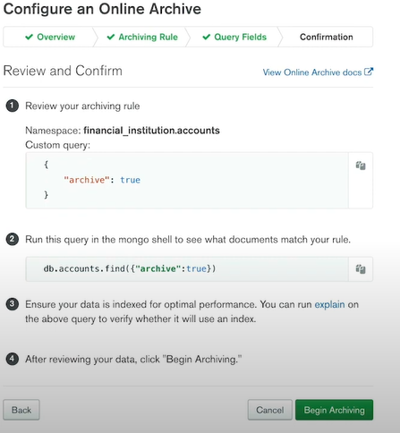

Step 6: Click on “Confirm”

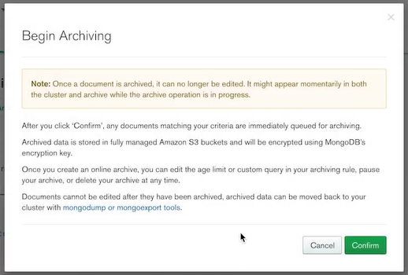

**Once done – the documents with the field setting {archive: true} will be archived**